HR MANAGEMENT USER MANUAL

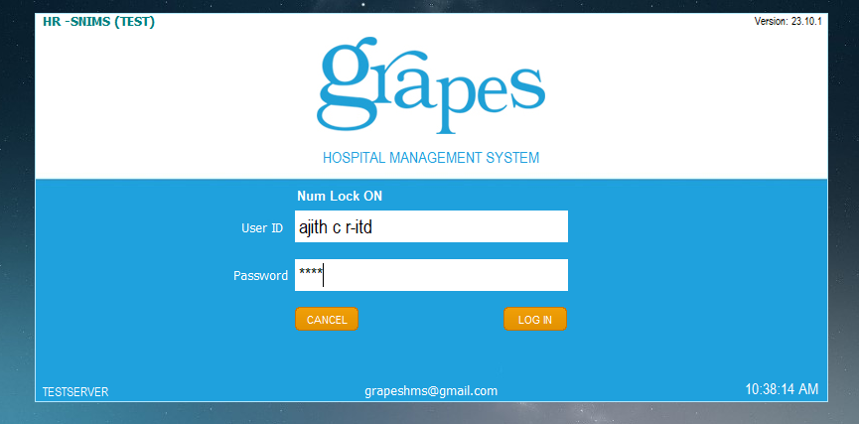

Enter the user ID and Password click Login

Employee Registration

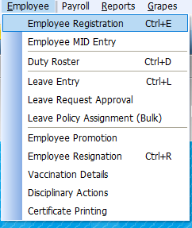

Click Employee Registration

(ctrl+E)

Employee Registration Form

Department and Designation Master

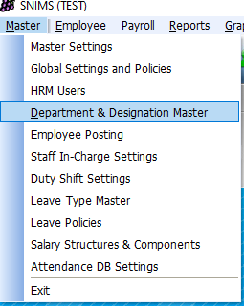

Click Master and select Department & Designation Master

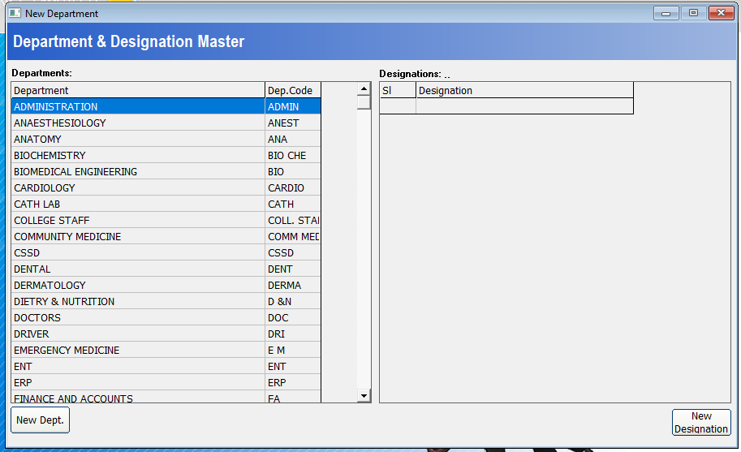

Creating New Dept,New Designation

Creating New Department

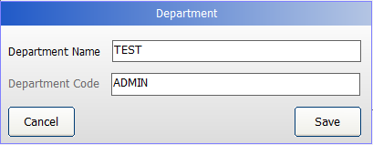

Click Save Button

Creating New Designation

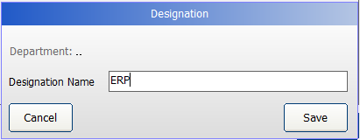

Click Save Button

Employee Posting

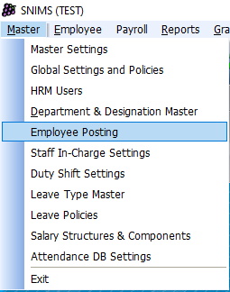

Click Master Select Employee Posting

Add New Post Type

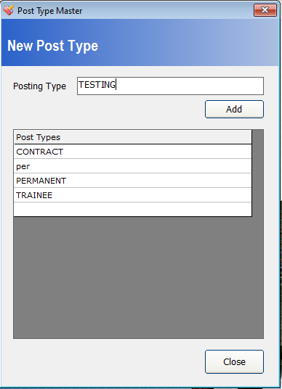

Enter Posting Type Click Add

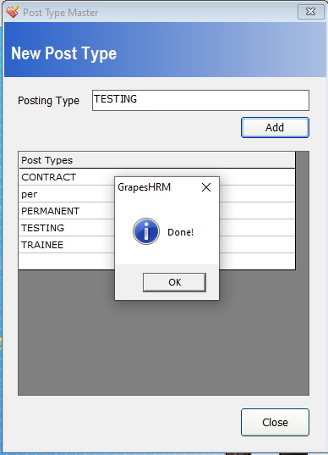

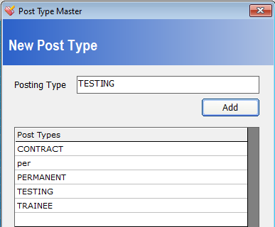

Post Types Added in Post Types

Staff in-charge setting

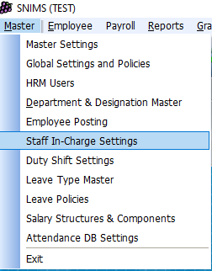

Click Master Select Staff IN-Charge Setting

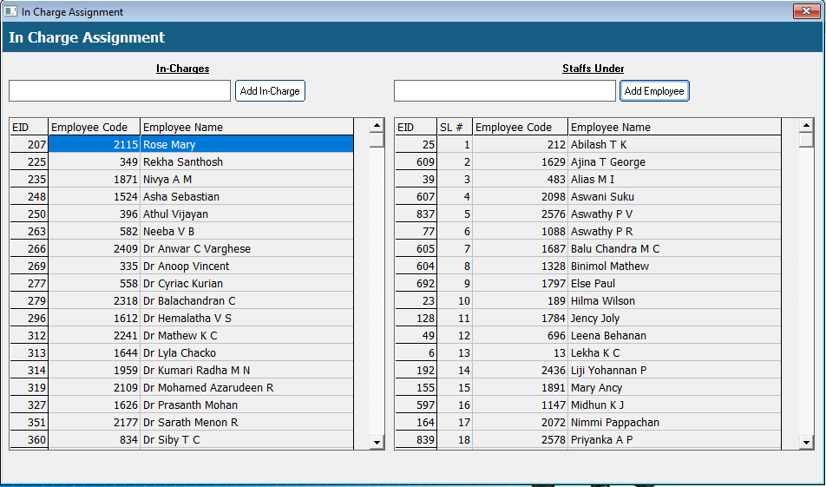

Add In-Charge and Add Employee

Duty Shift-Setting

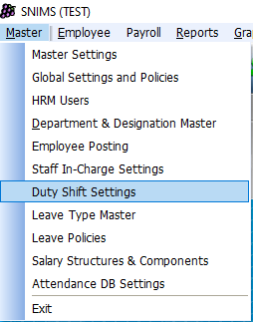

Click Master Select Duty Shift Setting

Duty Shift Master

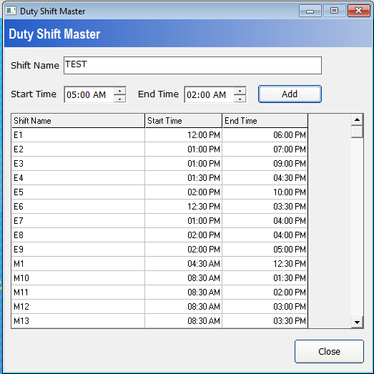

Enter Shift Name & Time and Click Add

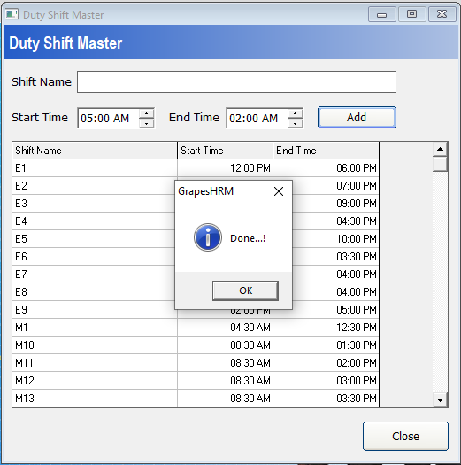

Click Ok Duty Shift added

Leave Type Master

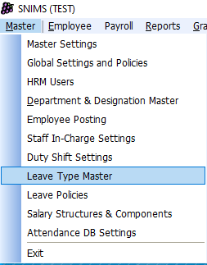

Click Master Select Leave Type Master

New Leave Types & Add New Leave Types

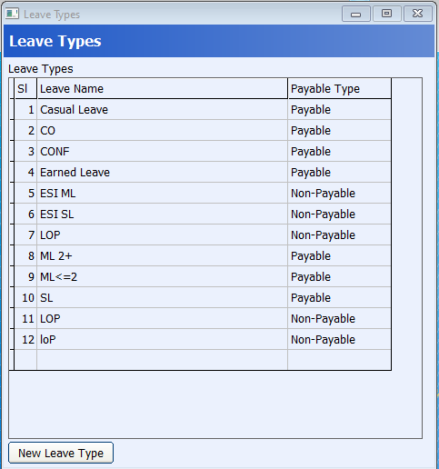

Click New Leave Type

Add New Leave Type

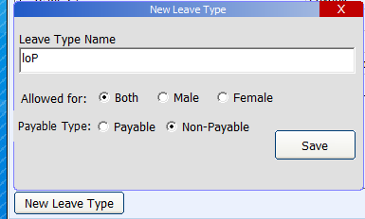

Add Leave Type Name and Select Allowed For & Payable Type

Leave Policies

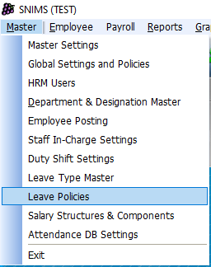

Click Master and Select Leave Policies

Leave Policy

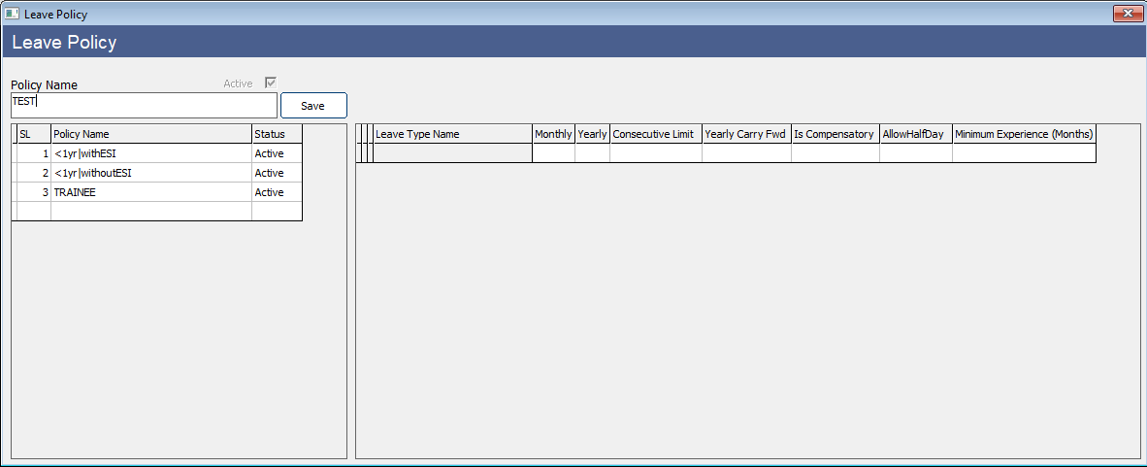

Add Policy Name And Click Save

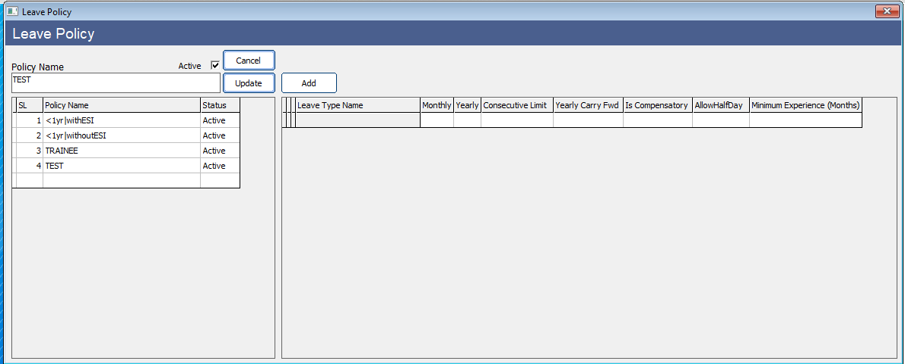

Click Add

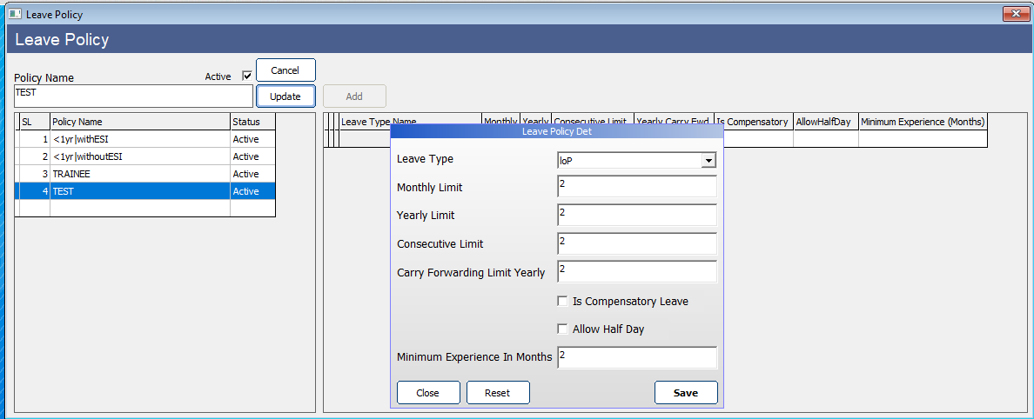

Enter Leave policy Details Click Save

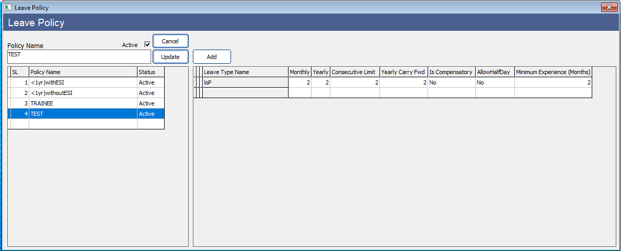

Leave Policy Update Details Added in Table

Remove Leave policy

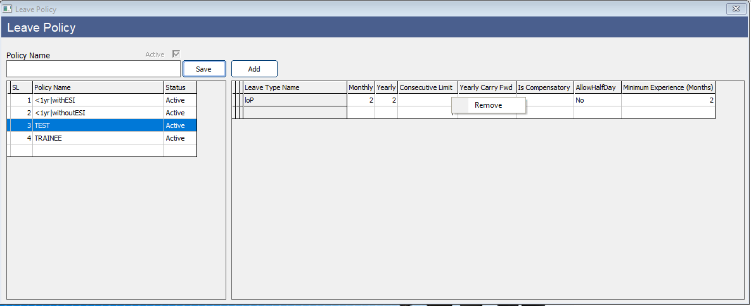

Right Click and remove

Salary Structure and Component

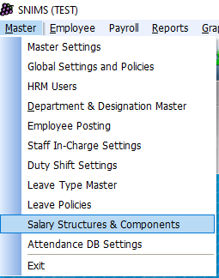

Click Master Select Salary Structures & Components

Salary Structure and Components

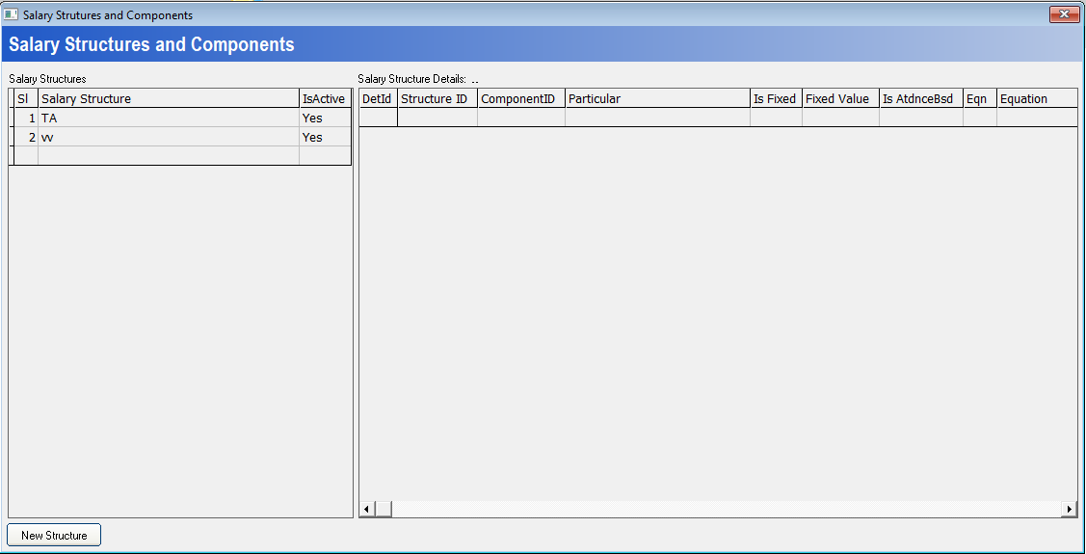

Click New Structure

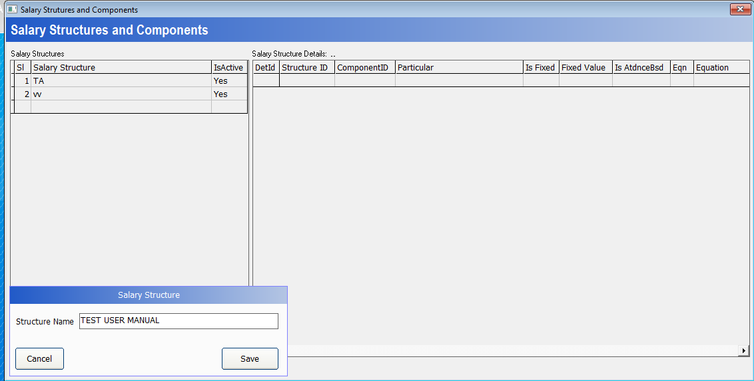

Add New Structure Name

Attach Component

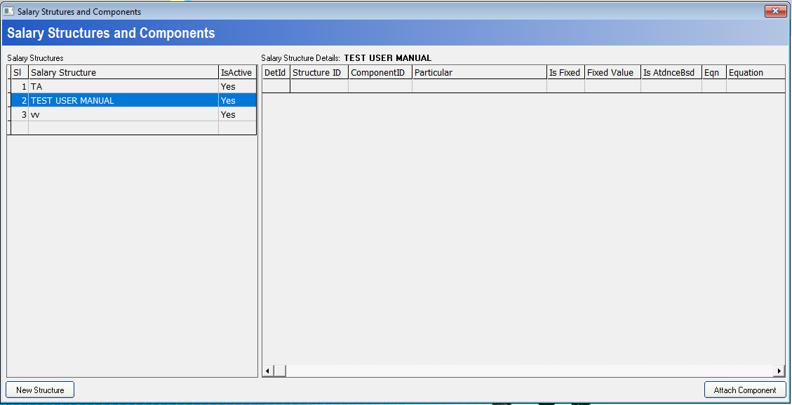

Click Attach Component

Salary Structure

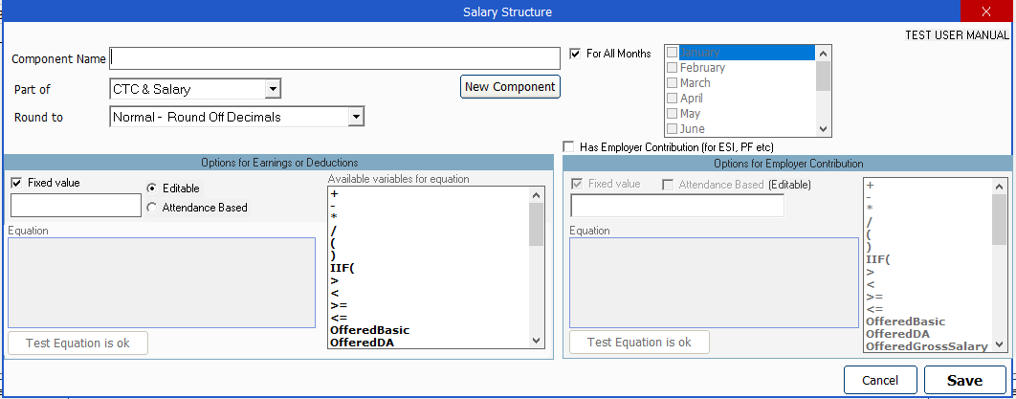

Click New Component

Add New Component

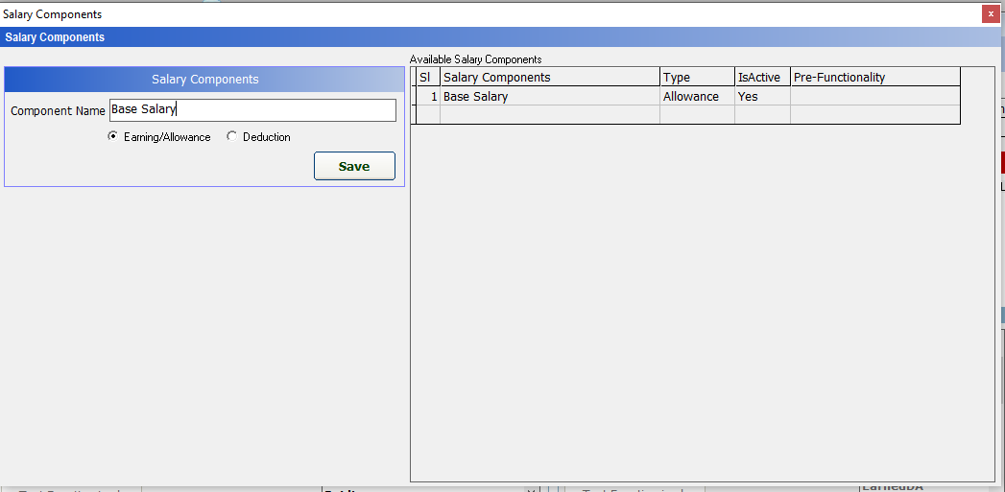

Enter Component Name Click Save

Options For Earnings or Deductions

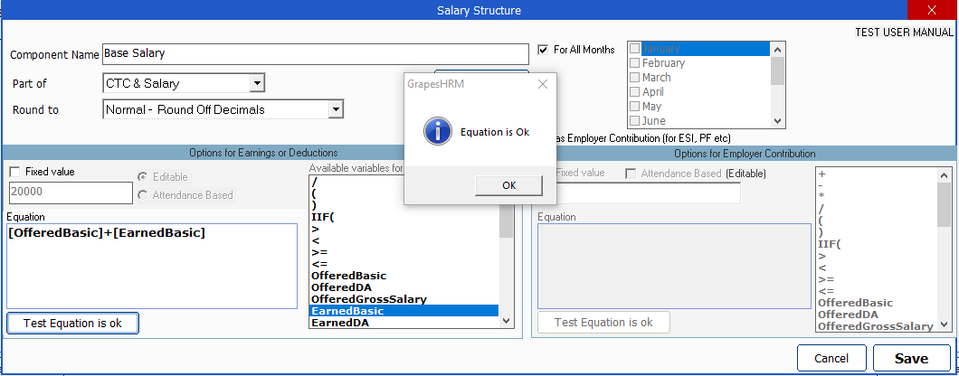

Enter Equation and Click Test Equation is OK

Employee Contribution ESI PF

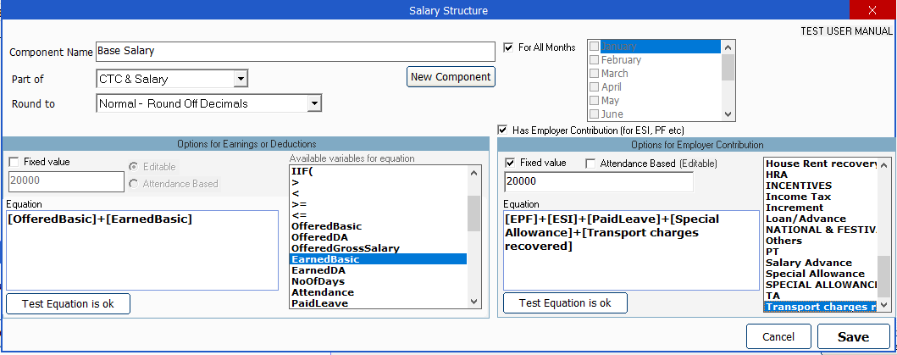

Enter Equation and Click Test Equation Is OK

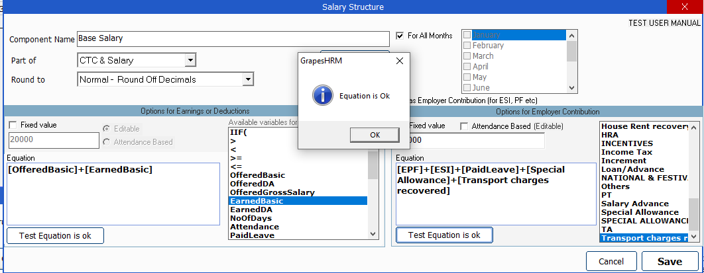

Click Ok and Click Save Button

Salary Structure Details

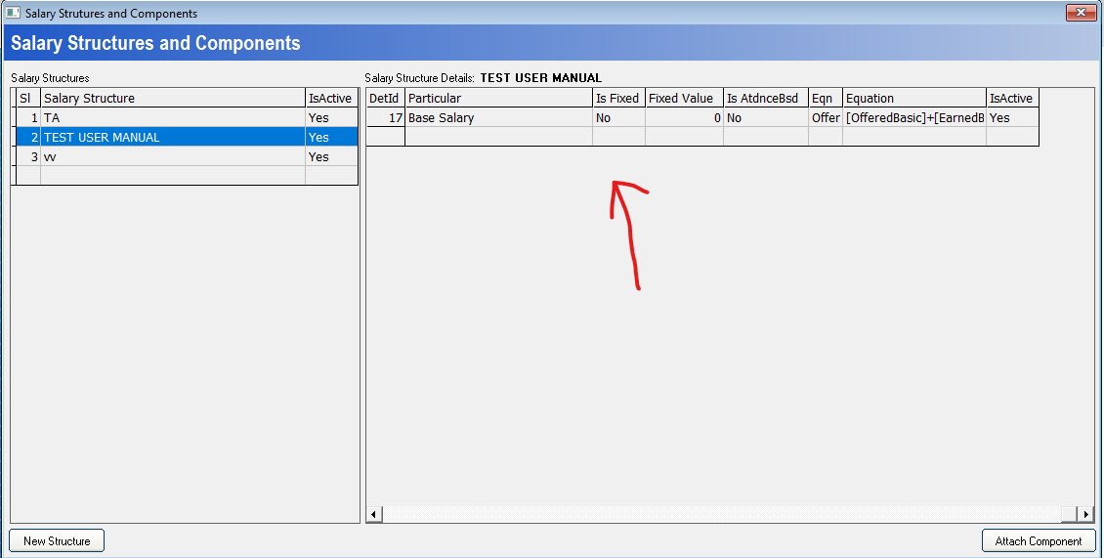

Employee MID Entry

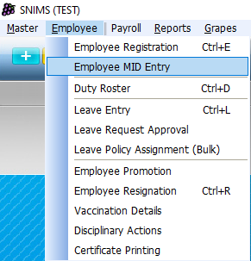

Click Employee Select Employee MID Entry

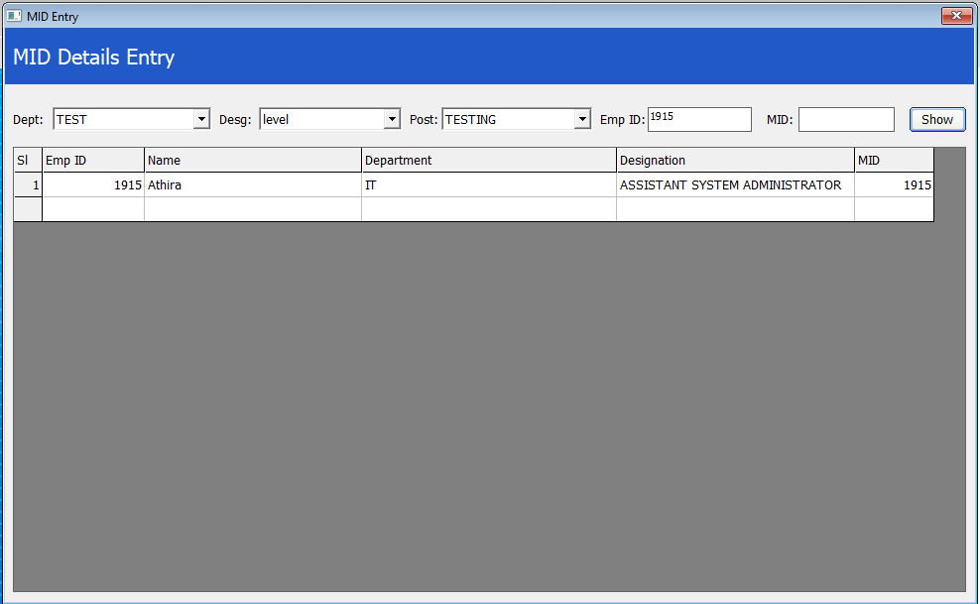

Select Department ,Desgination ,Post ,Emp ID

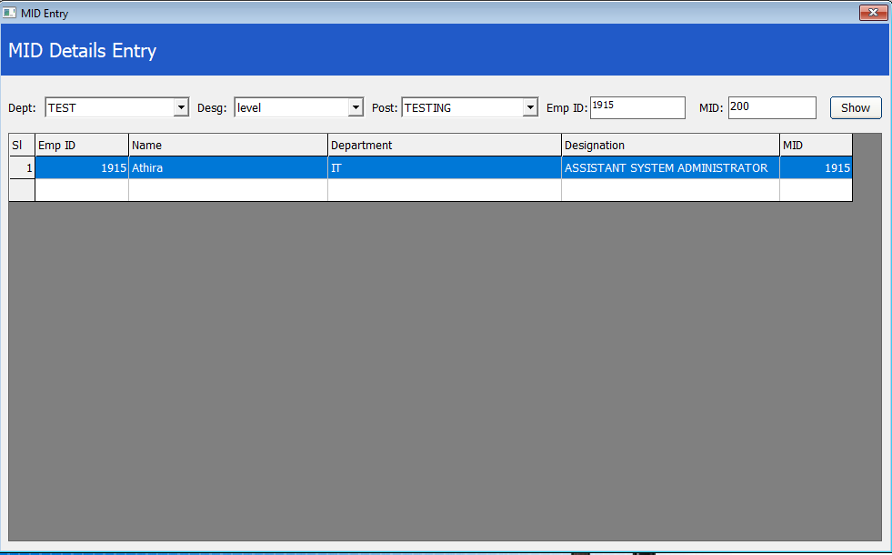

Click Row

Enter MID Number

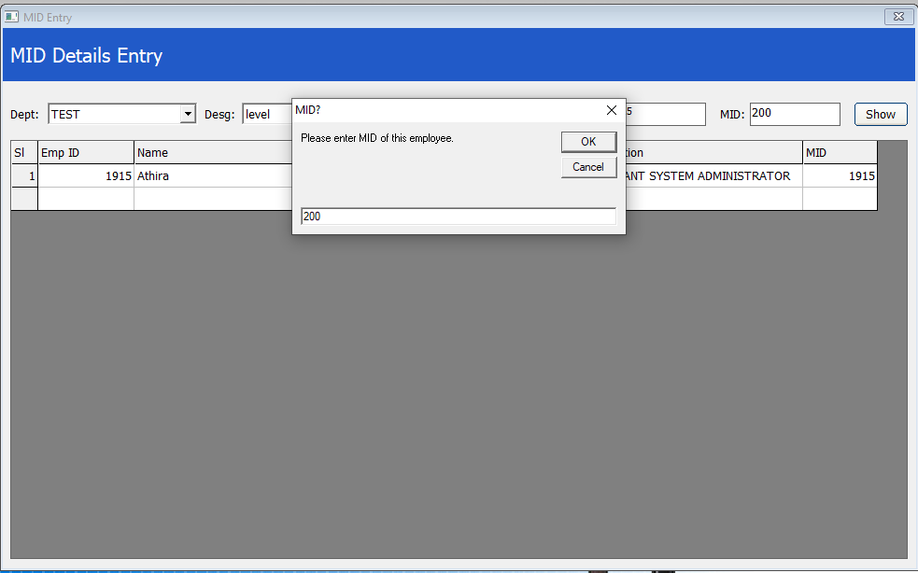

Enter MID Number and Click ok

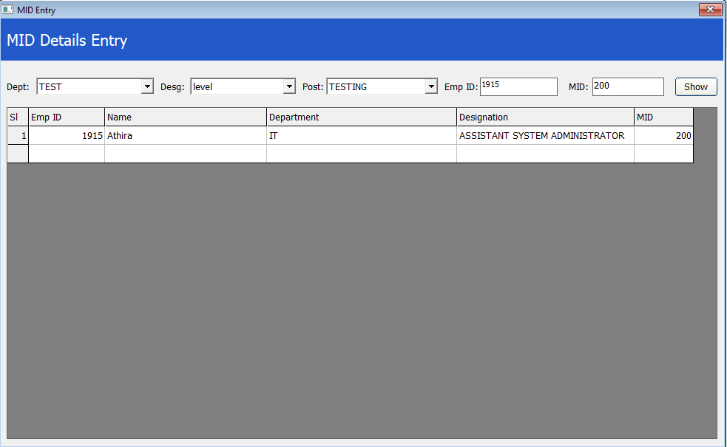

MID Number Added

Duty Roaster

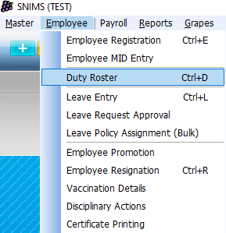

Click Employee and Select Duty Roaster

(Ctrl+d)

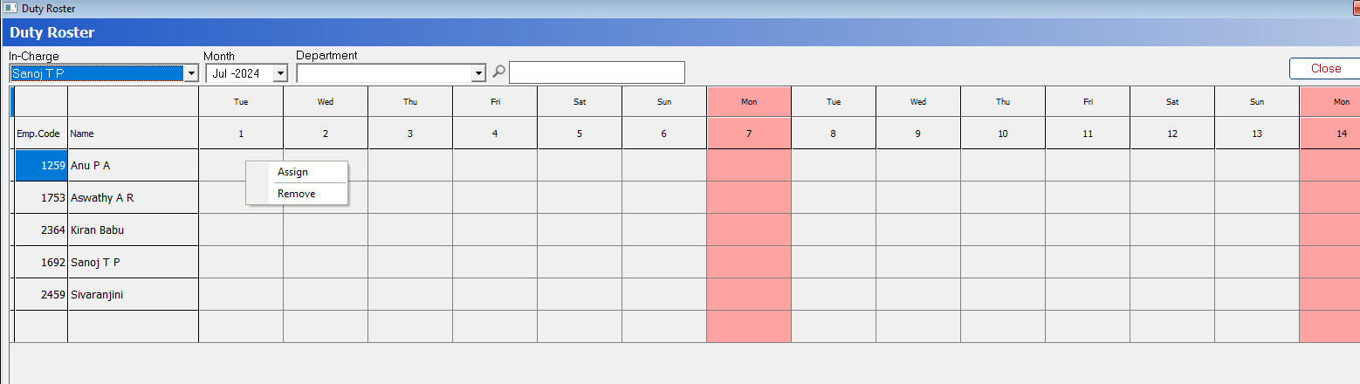

Click Left Click and Click Assign Shift

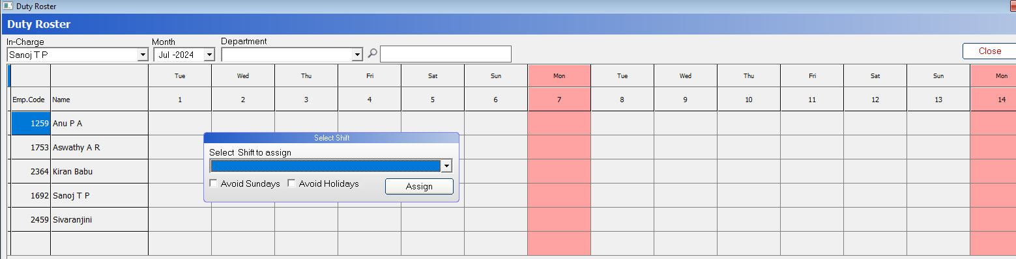

Select Shift Assign IF Avoid Sundays & Holidays Click Check Box

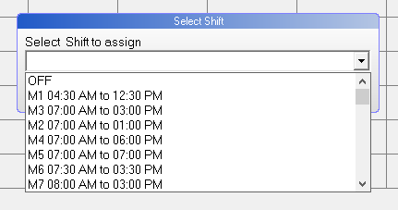

Select Shift Timing

Select Shift to Assign

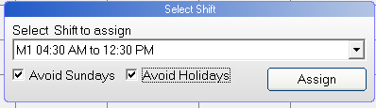

Click Assign Button

Assign Shift

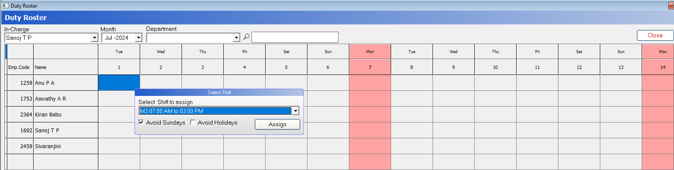

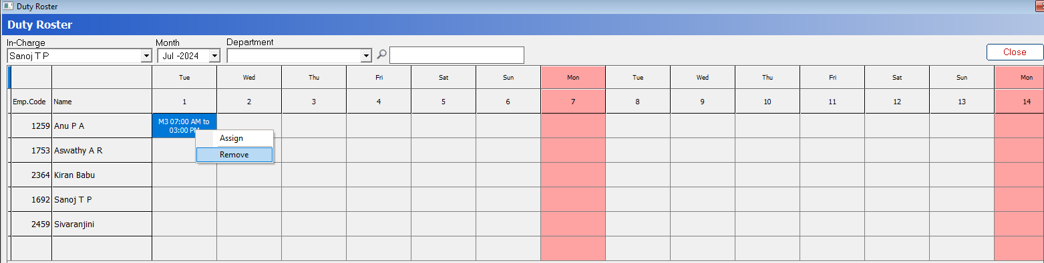

Shift Assigned

Duty Assigned For full Table employees

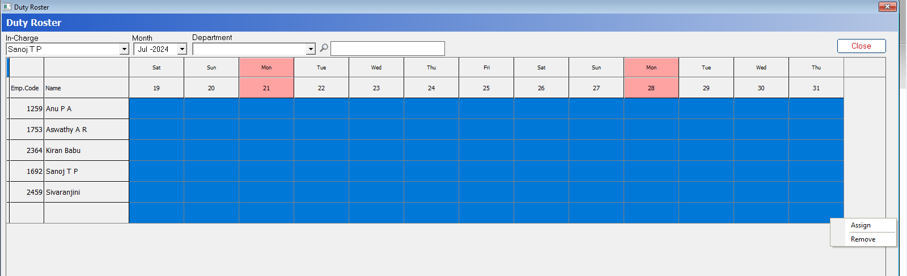

Select All row and Coloumns Assign Duty

Duty Assign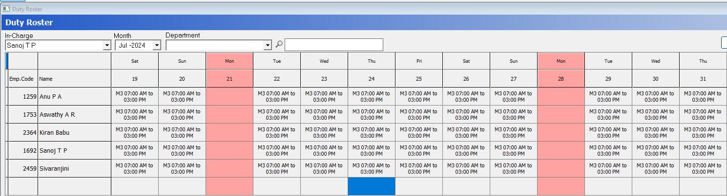

Removing Assinged Duty



Right Click and Click Remove

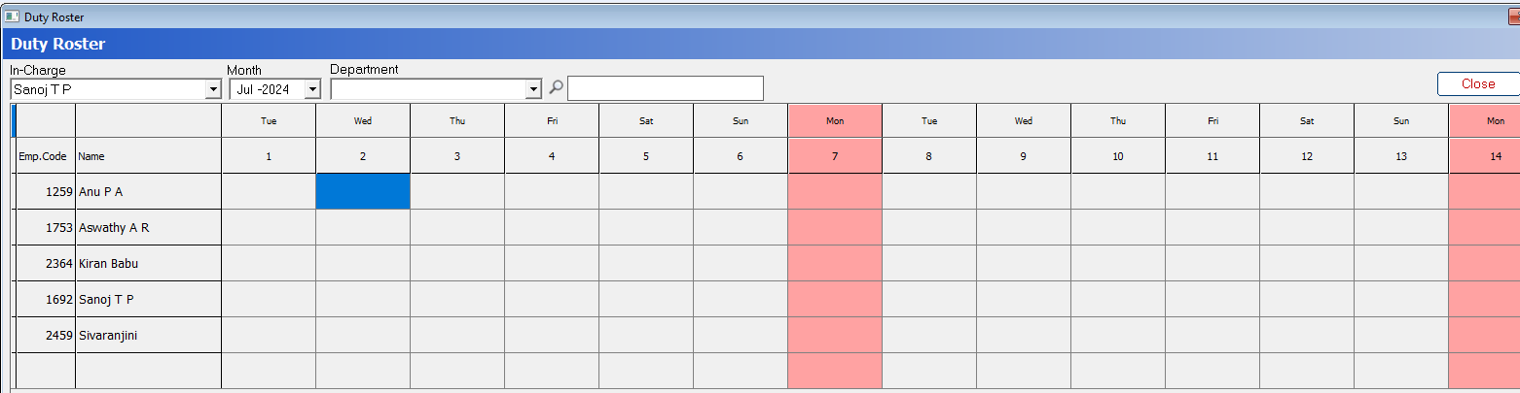

Assigned Duty Removed

Leave Entry

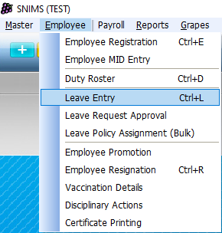

Select Employee Click leave Entry

(Ctrl+l)

Leave Register

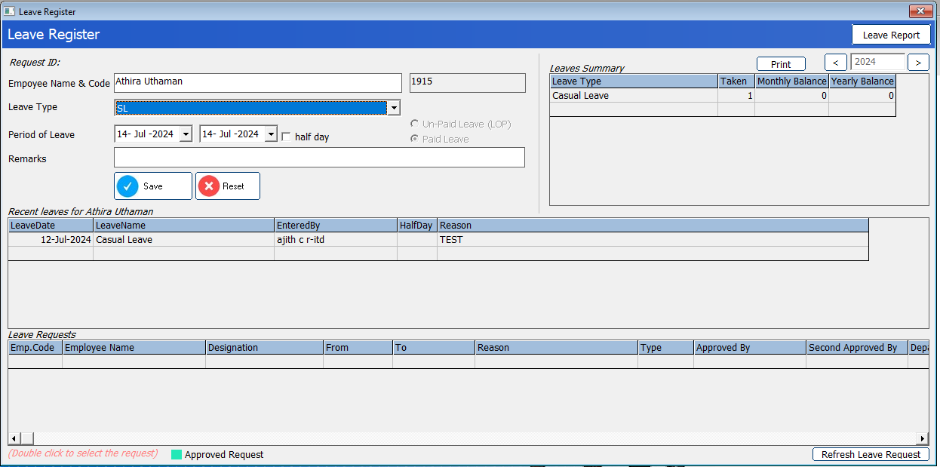

Enter Employee Name & Code

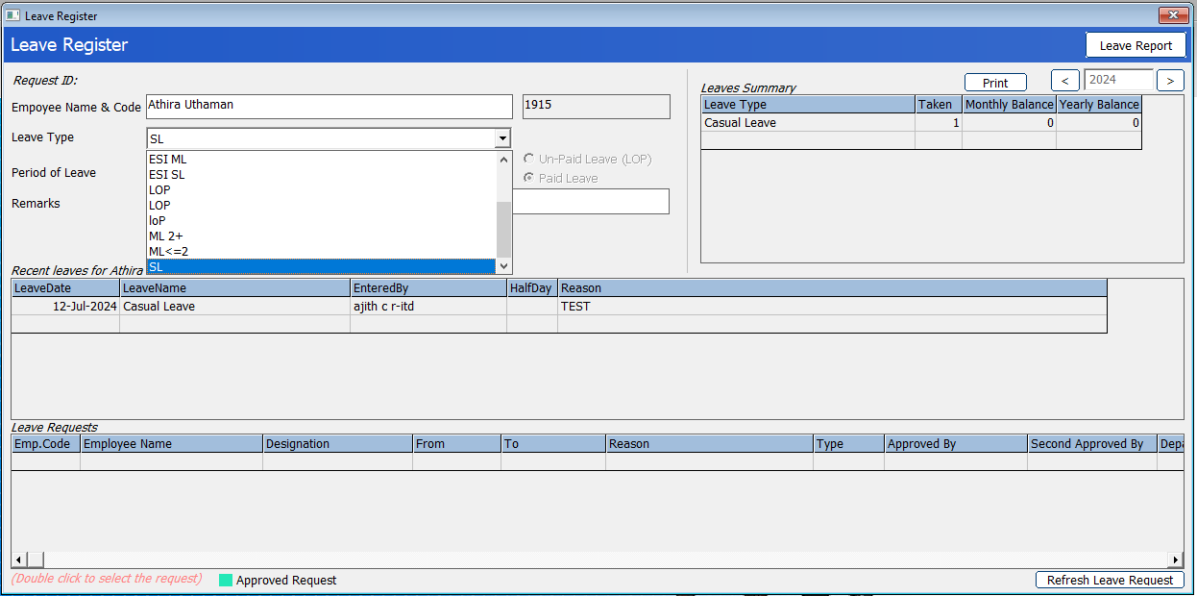

Select leave Type

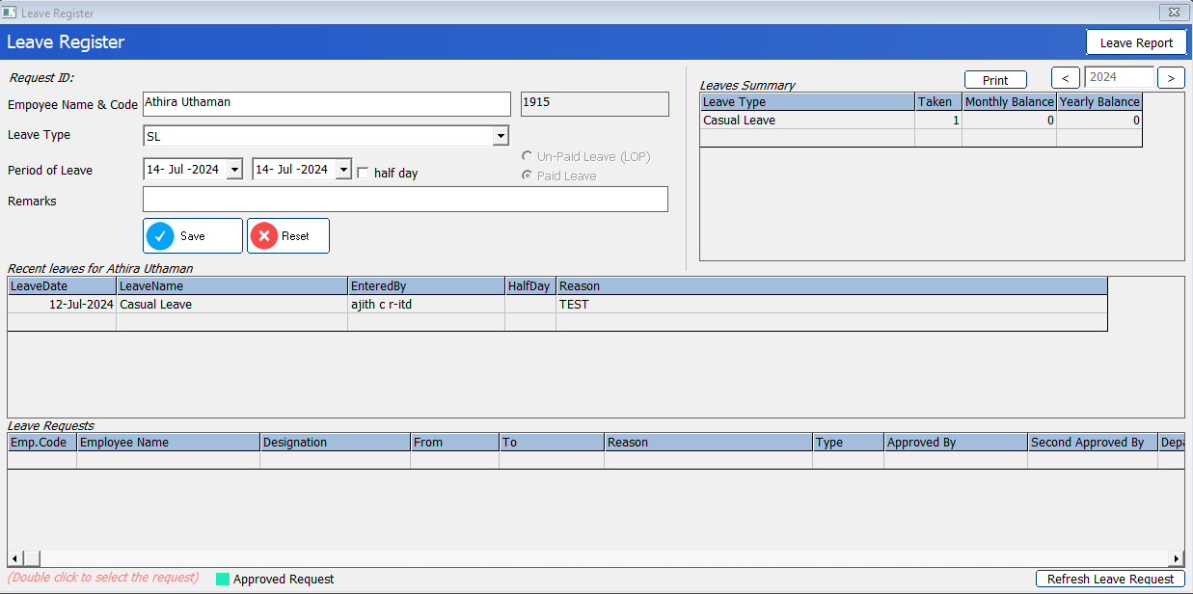

Select Period Of Leave

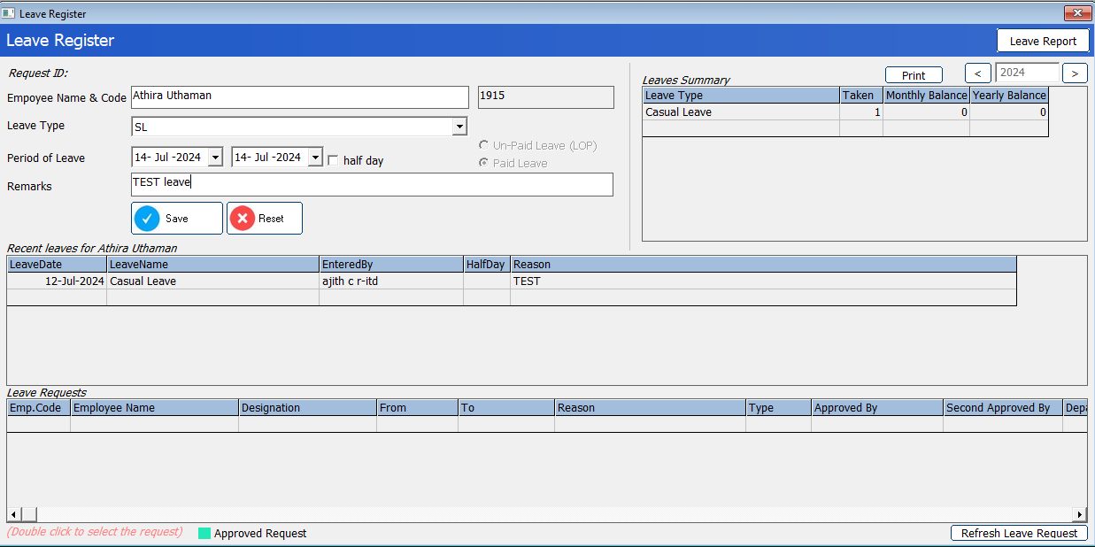

Enter Remarks Click Save

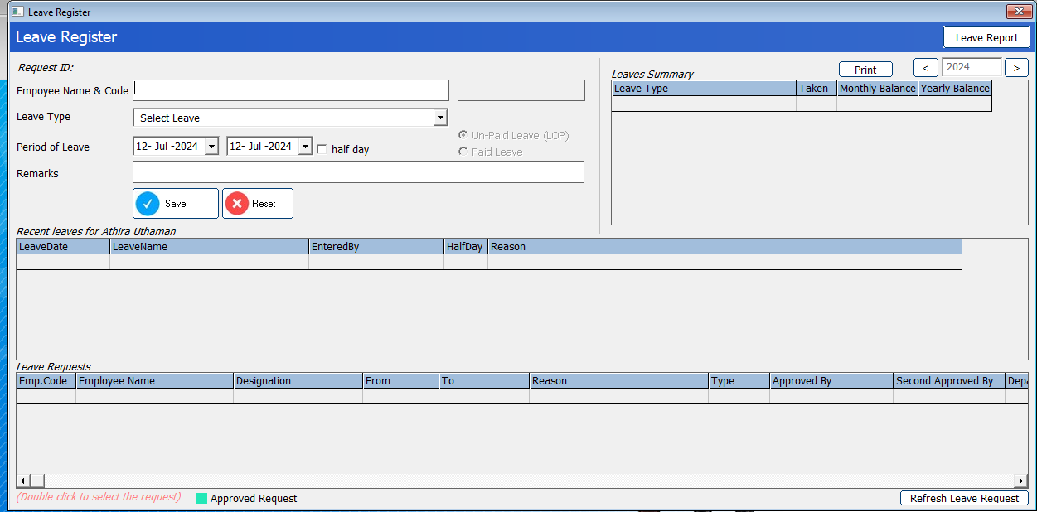

Click leave report

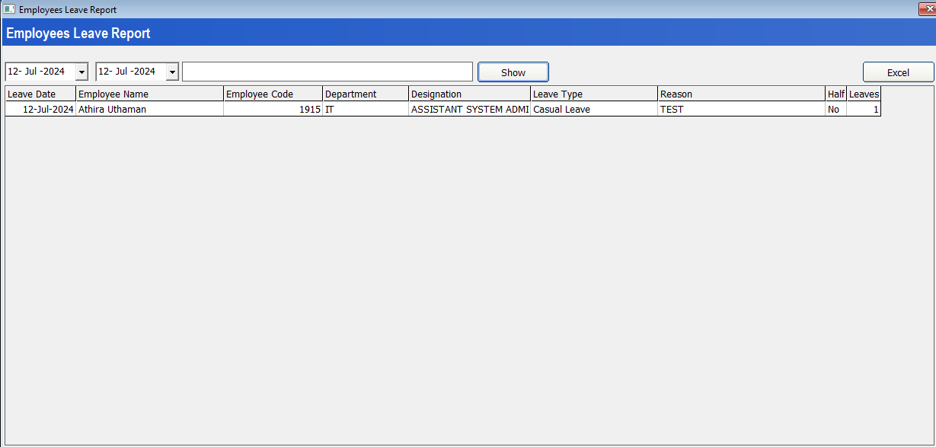

Select Date and Click Show

Leave Request Approval

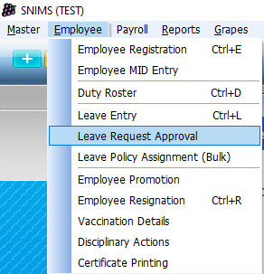

Click Employee Select Leave Request Approval

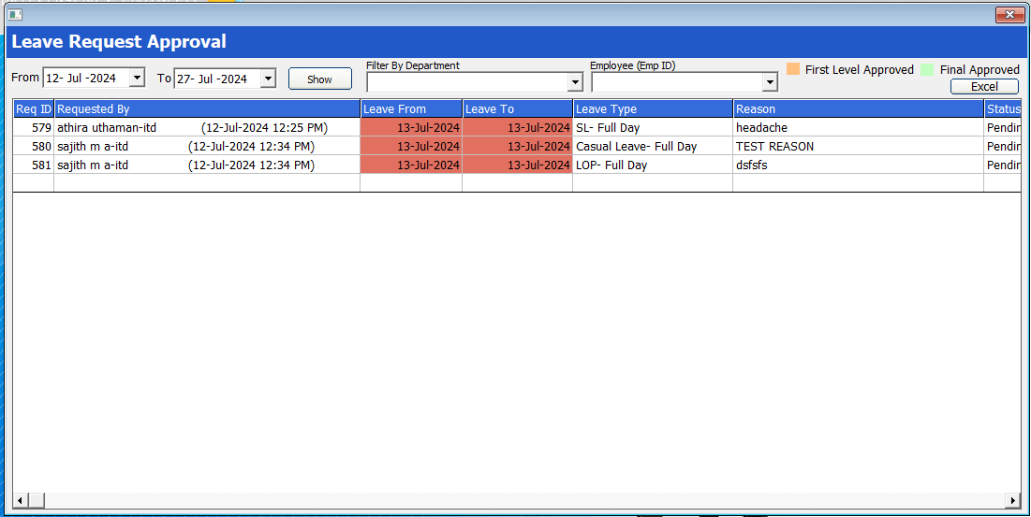

Request will show in Leave Request Approval

First Approval

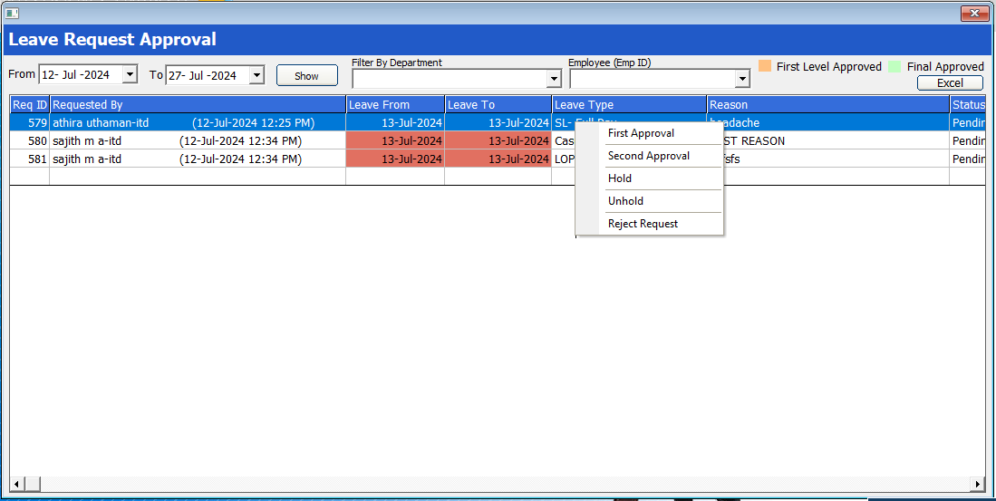 Right Click and Select First Approval

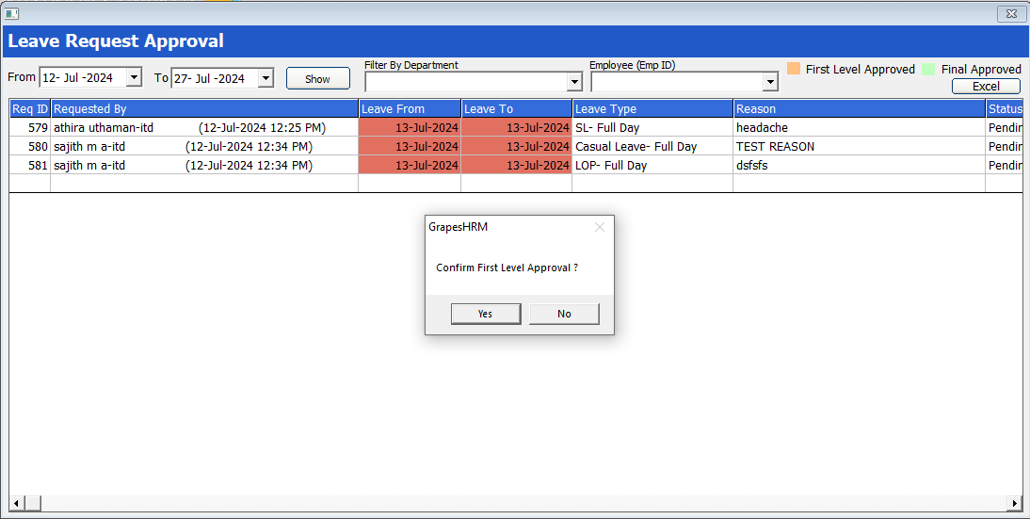

Click Yes To confirm Firs Level Approval

First level Approval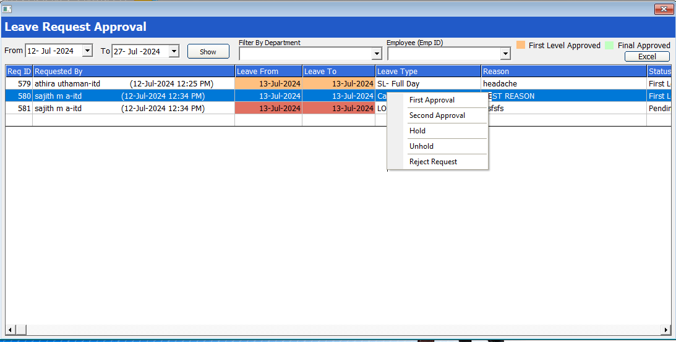

Second Level Approval



Hold leave

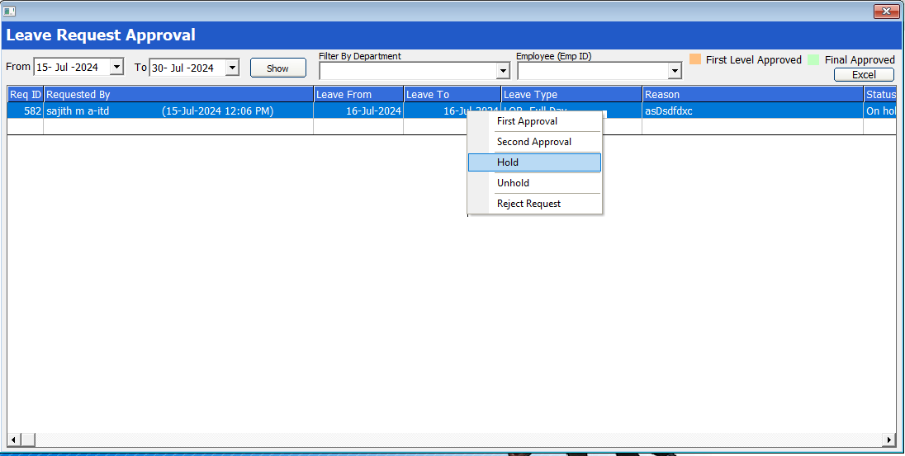

Un Hold leave

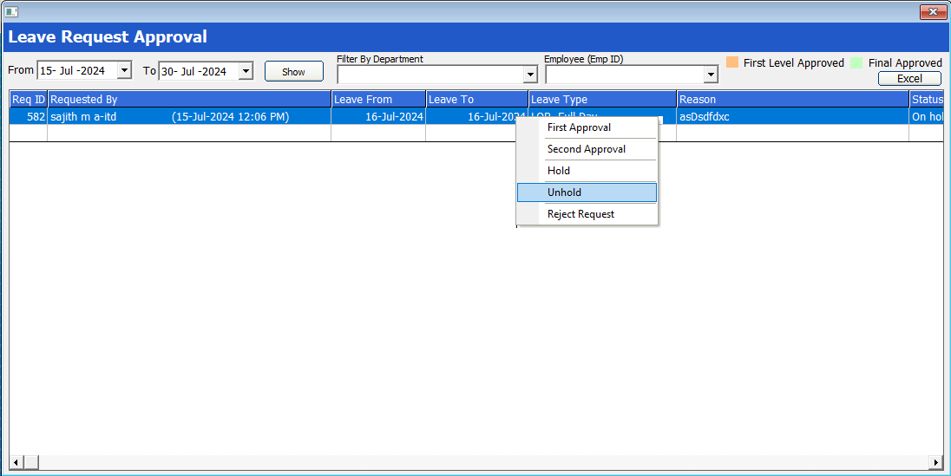

Reject Request

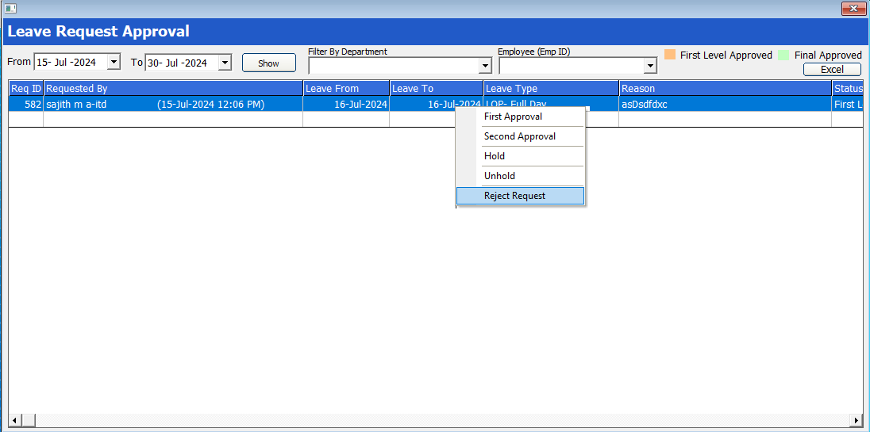

Leave Policy Assignment

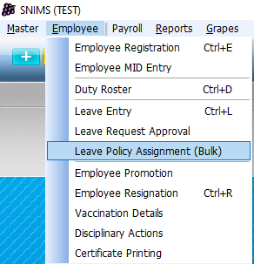

Select Department

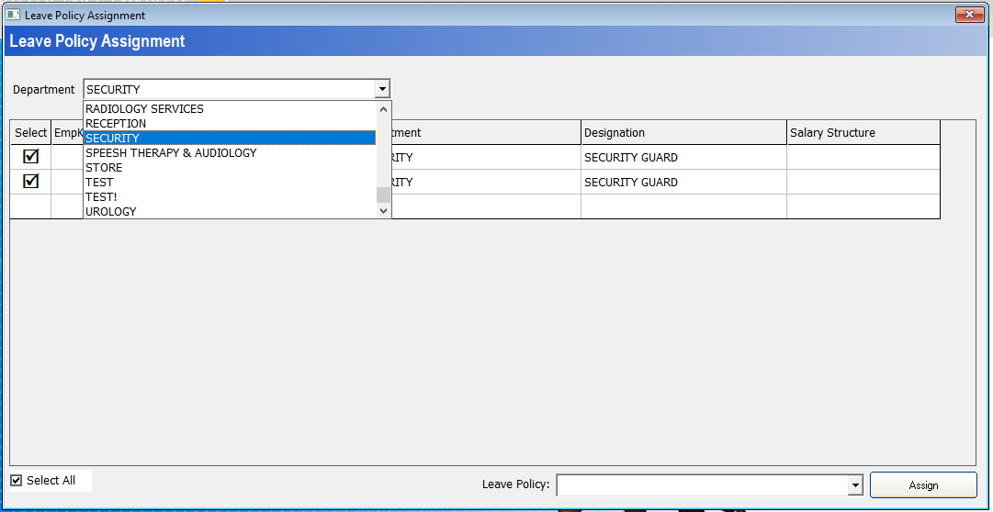

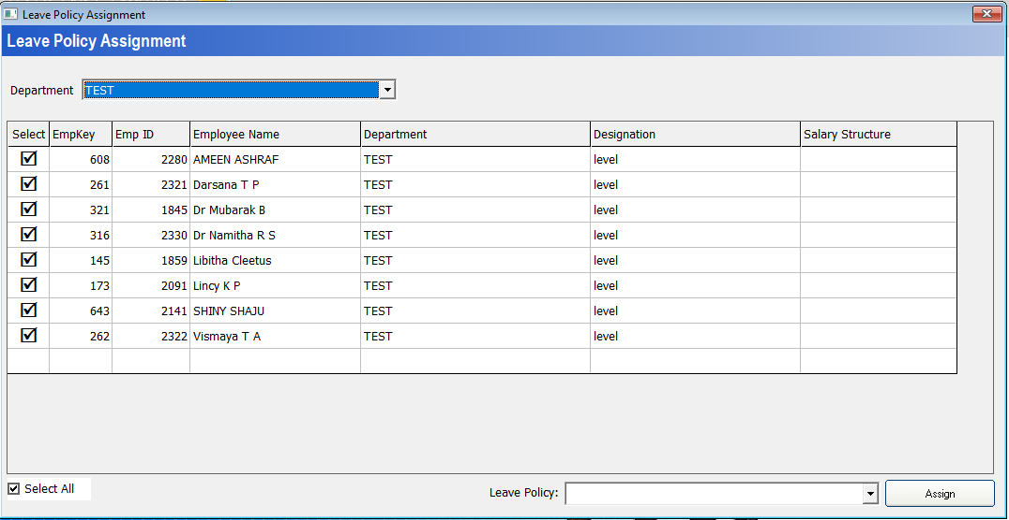

Selecting All Employee ✔ Select All

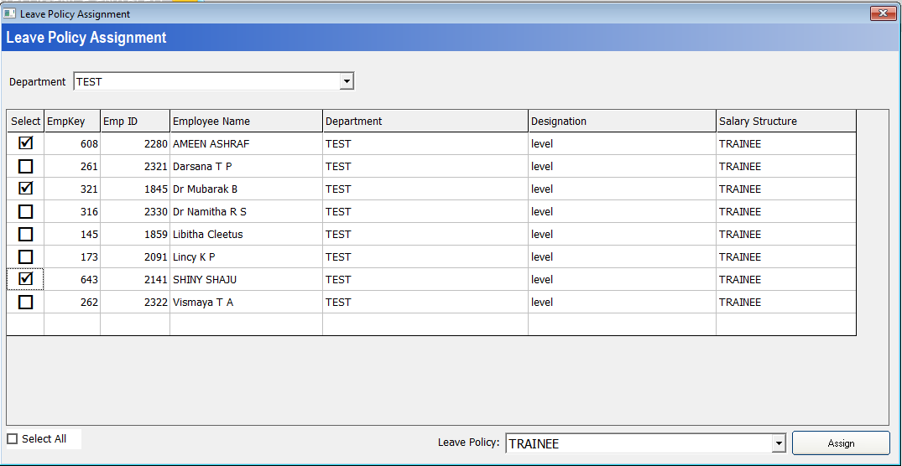

Selecting Specific Employee

Assign Leave Policy

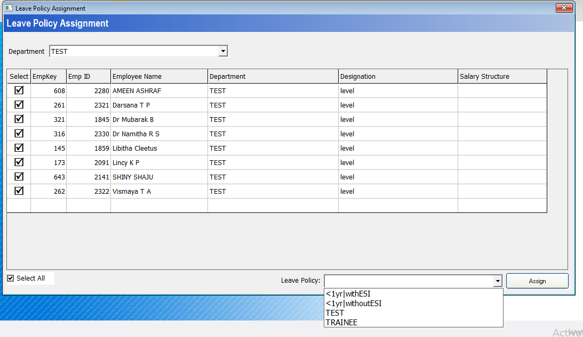

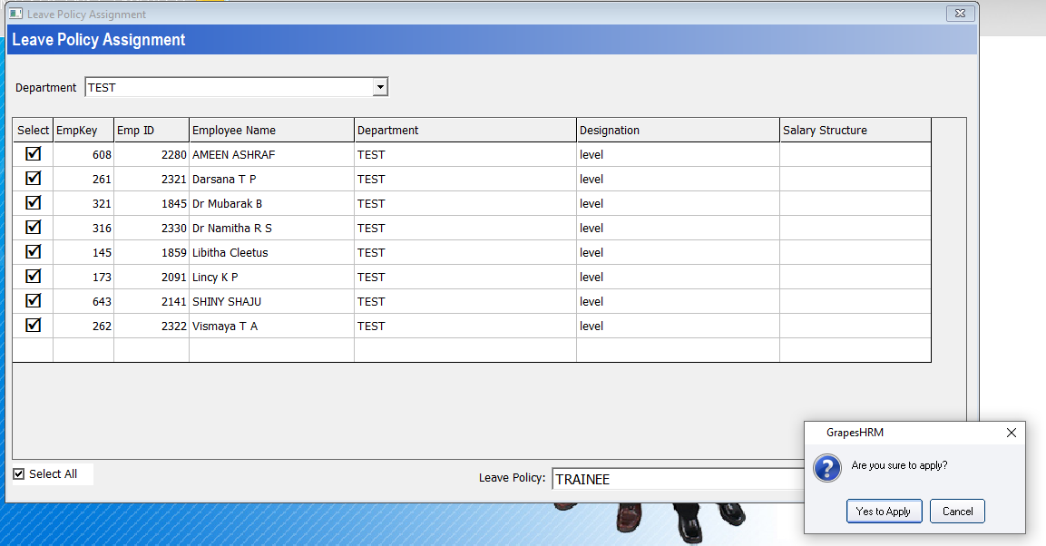

Click Yes to Apply

Employee Promotion

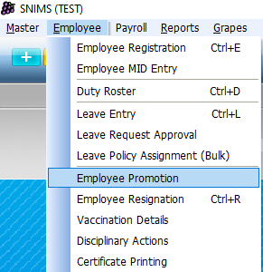

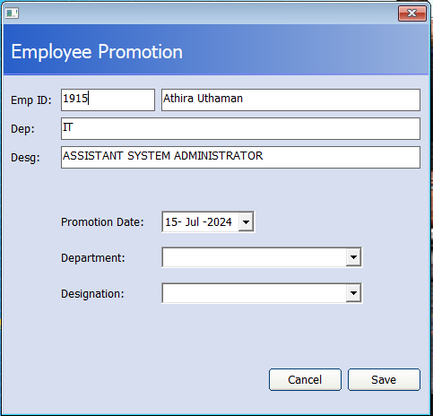

Select Employee ID

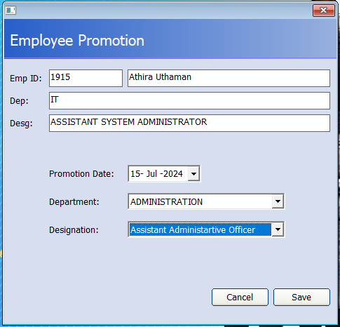

Select Date & Department & Designation

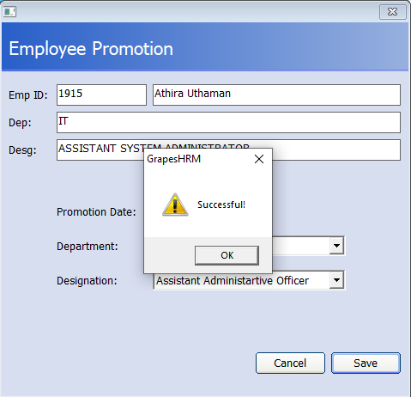

Click Save Button

Employee Resignation

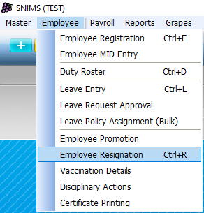

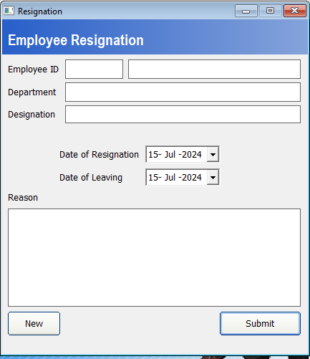

Click Employee ID

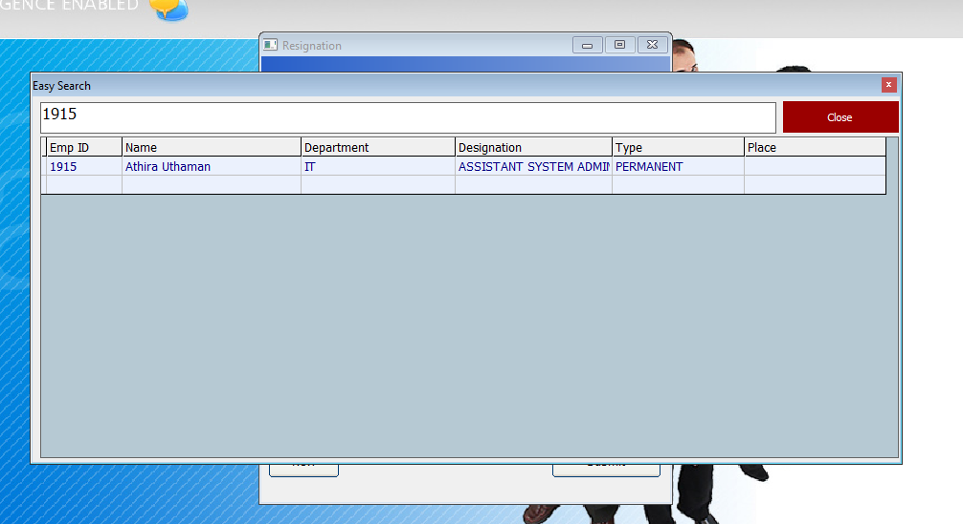

Enter Employee Name or ID

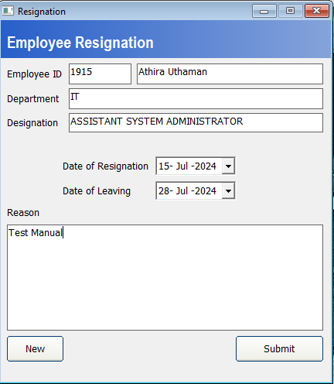

Select Date of Resgination & Leaving

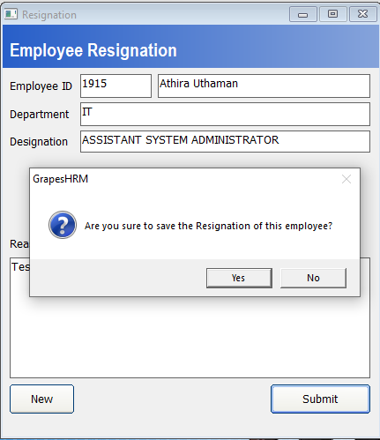

Click Submit button

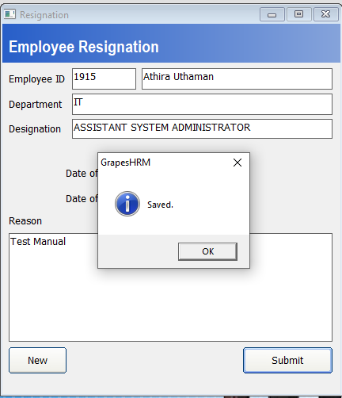

Click ok

Vaccination Details

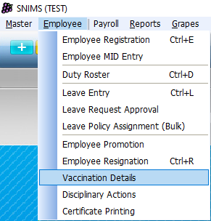

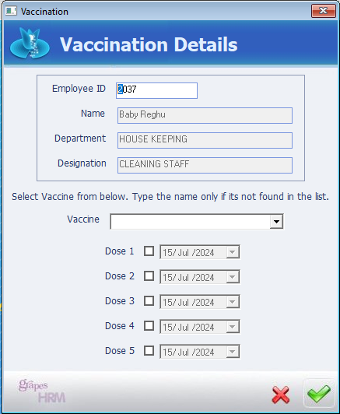

Select Employee ID

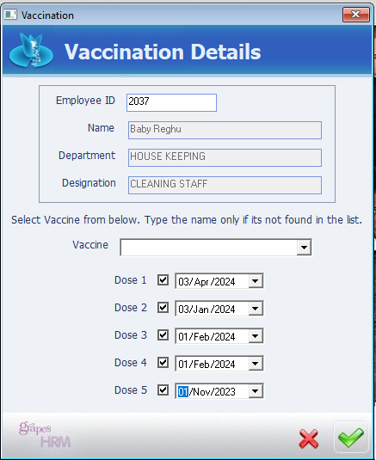

Select Dose list and Date

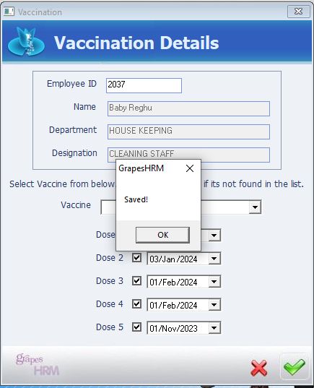

Click ok

Certificate Printing

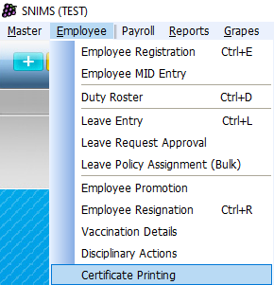

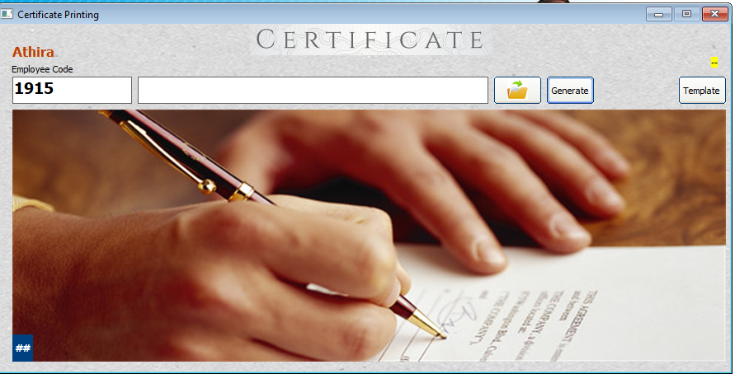

Select Employee Code

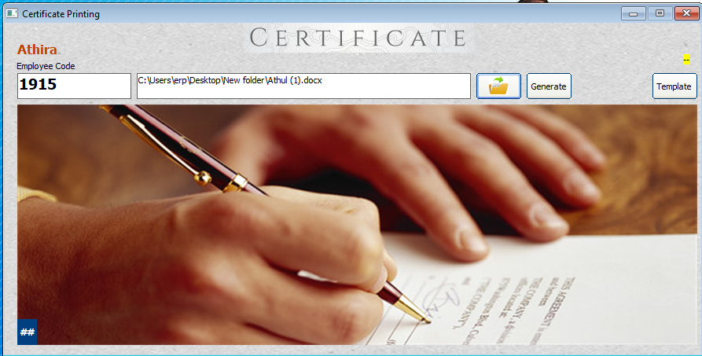

Select File and Click Generate , Add Template also Avalaible

Salary Structure Assignment

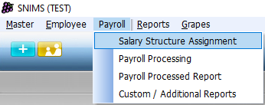

Salary Structure Assignment

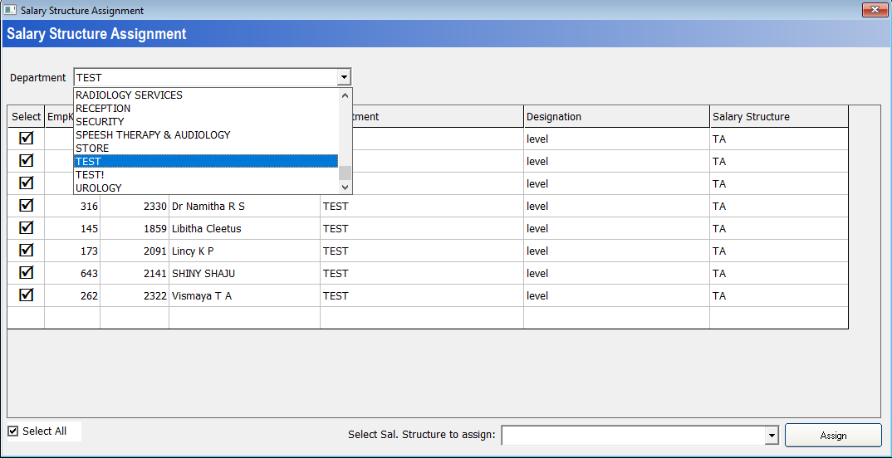

Select Department

Select Salary Structure

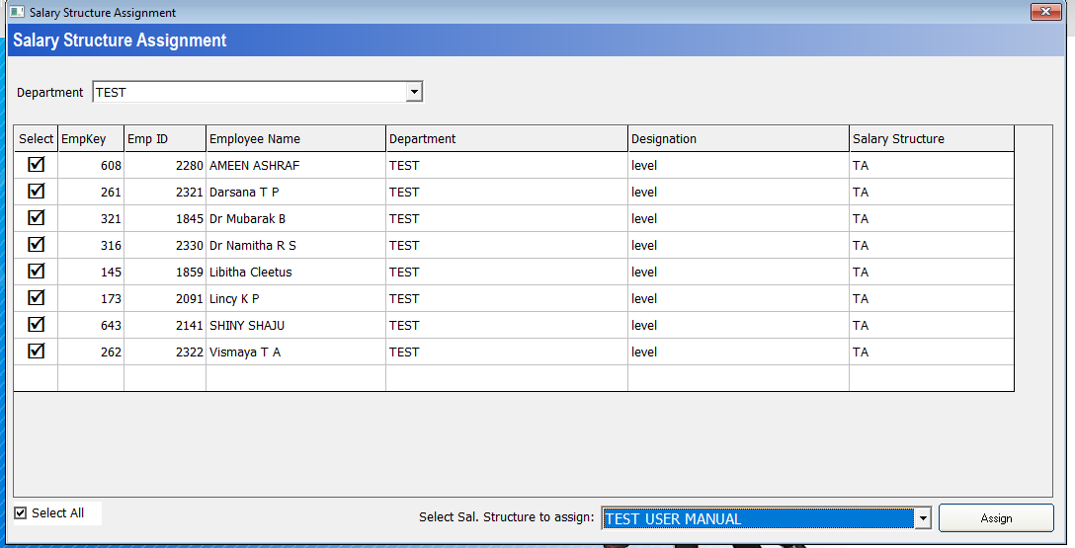

Click Assign Button

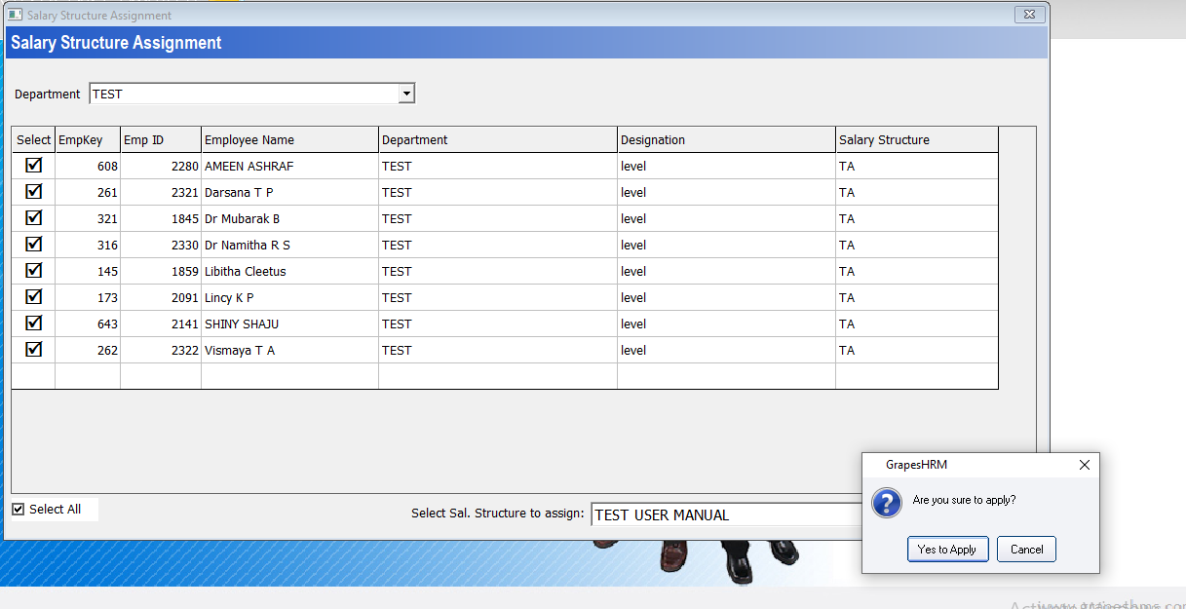

Click Yes To Apply

Payroll processing

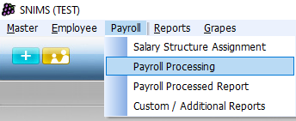

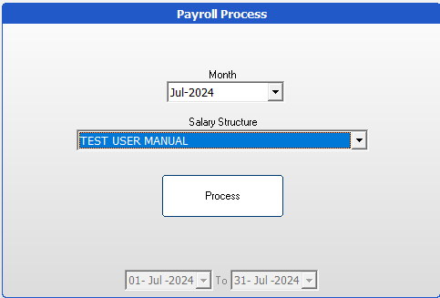

Select Month & salary Structure Click Process

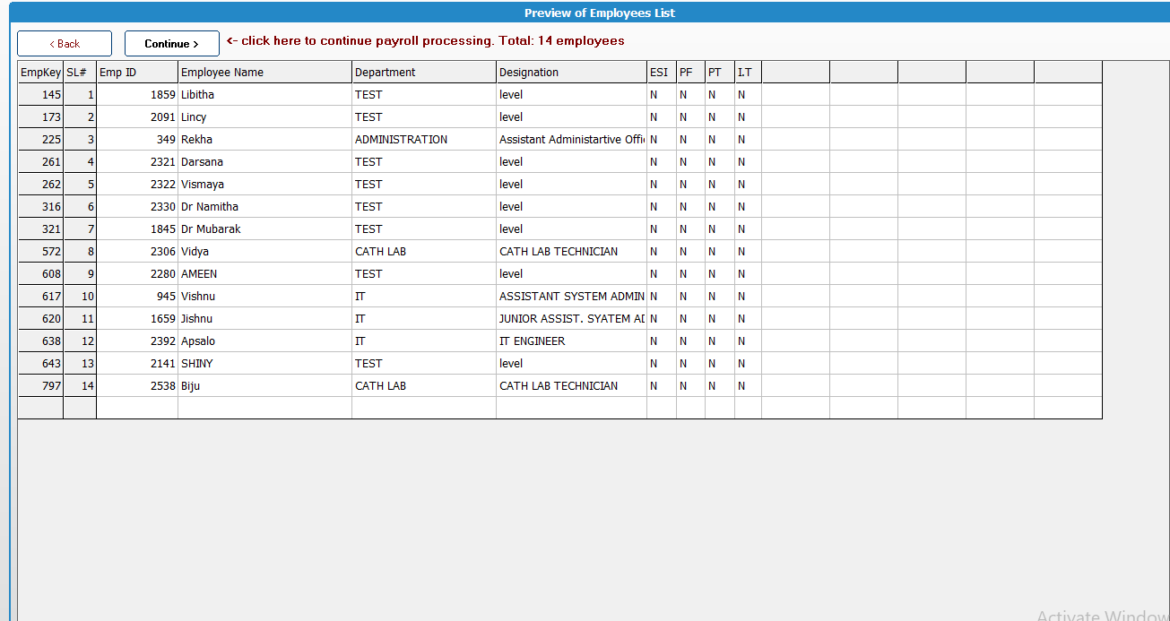

Click Continue Payroll processing

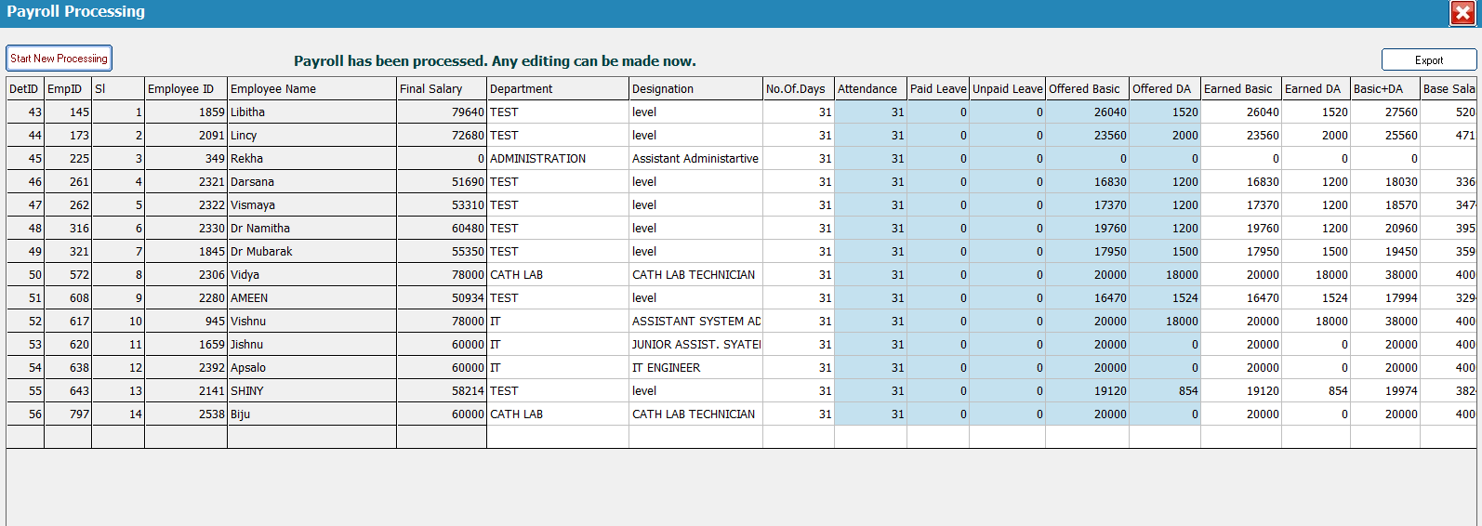

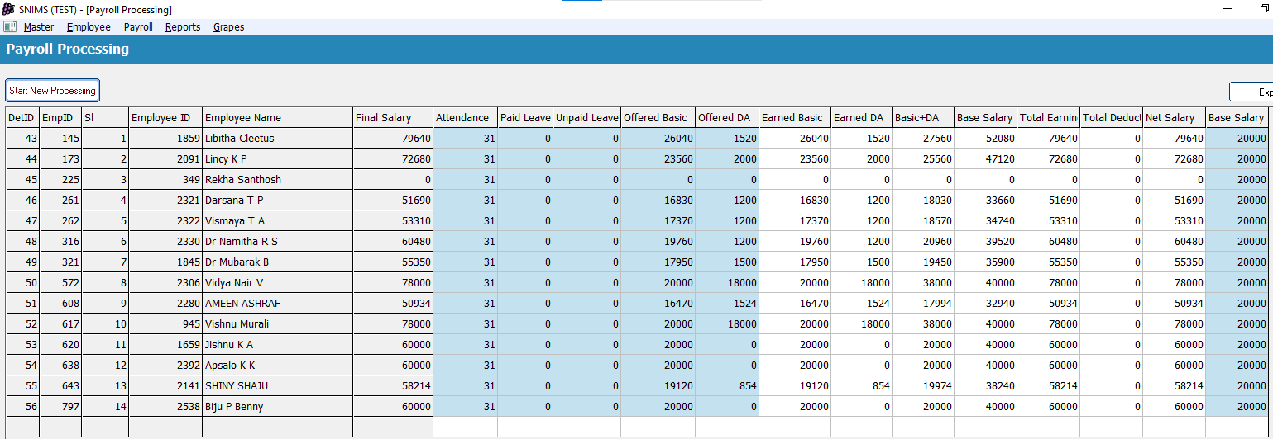

Payroll has Been process

Payroll Process Report

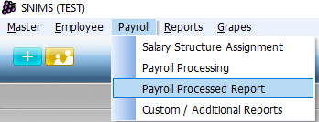

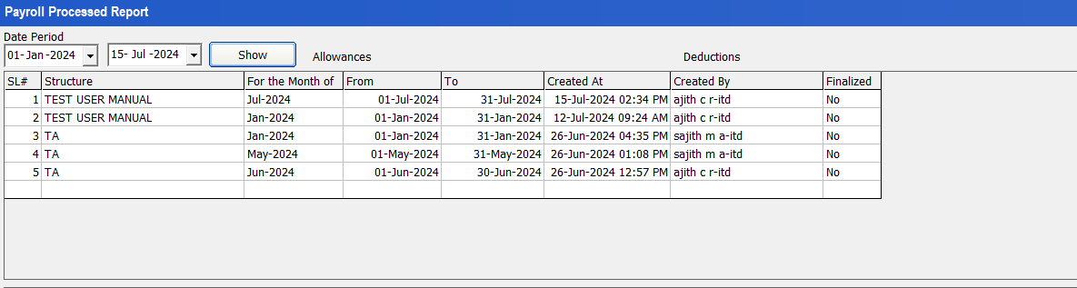

Select Date Click Show

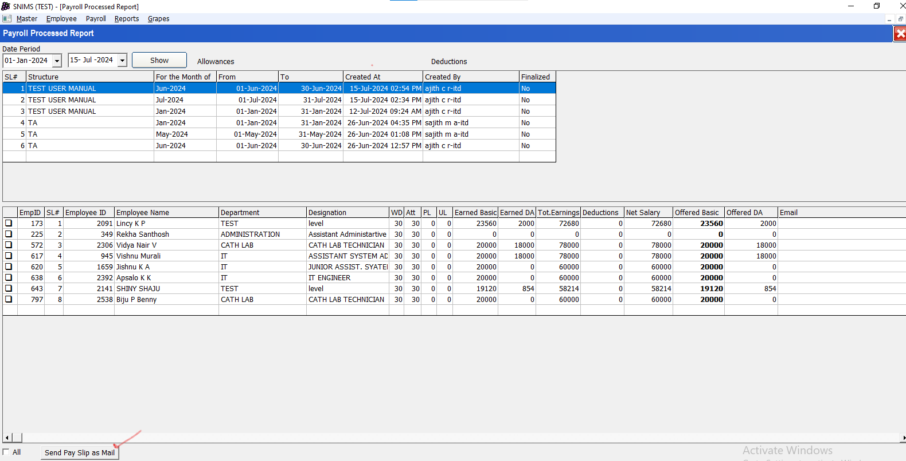

Click Salary Structure will be displayed list of under employee we Can send mail in Salary Slip

Custom Additional Report

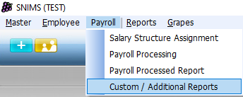

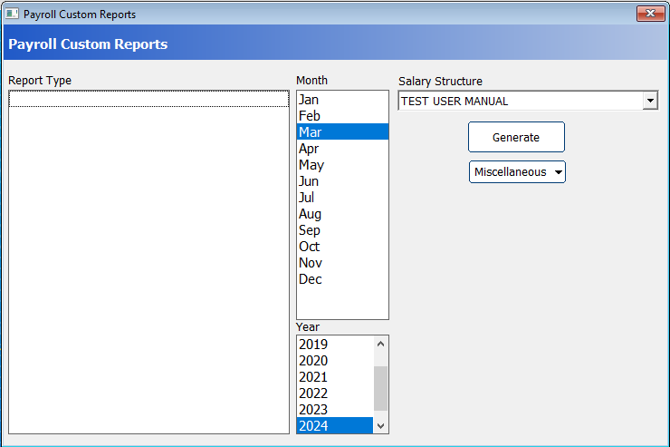

Click Generate

Reports

Employee Report

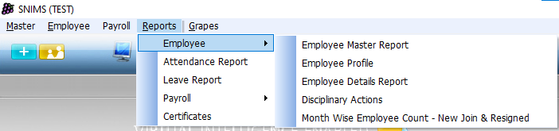

Attendance Report

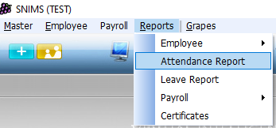

Leave Report

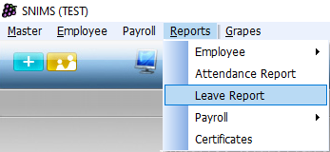

Payroll Reports

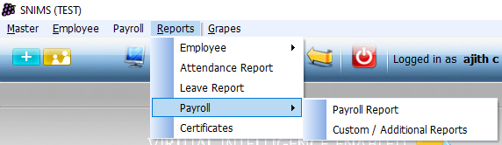

Master Setting

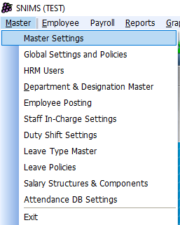

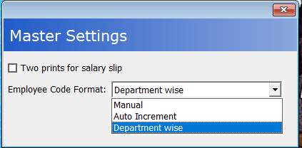

Exit

